Novel Energy Cured Mercapto Functional

Silicon Q Resin Materials for 3D Printing.

*1Bob Ruckle, 2Tom-Seung Cheung, 3John Grande, and 4Yanjun Luo*

*Siltech Corporation*

*Toronto, ON Canada*

[*1Robert@siltech.com*](mailto:1Robert@siltech.com)*,* [*2Tom@siltech.com*](mailto:2Tom@siltech.com)*,* [*3John.grande@siltech.com*](mailto:3John.grande@siltech.com)*, 4Yanjun.luo@siltech.com*

**Abstract**

Mercapto functional silicon-based Q resins are shown to be cross linked with vinyl silicone using UV light and photoinitiators. The materials are evaluated for physical properties and the best of these formulations are 3D printed to give soft, flexible white elastomeric material with up to 150% elongation.

**Introduction**

A series of mercapto functional silicon resins, with ultra-high cross-link density, are reacted with various vinyl silicones using UV light and photoinitiators. This reaction is well known and studied in the literature, our take on this is the use of these highly cross-linkable reactive resins.

Screening for maximum G’ with a rheometer and then making benchtop preparations, multiple structural and stoichiometric variables are evaluated for their effect on mechanical properties. These formulations are expected to be soft, so we are targeting a 3D printable material with Shore A hardness that shows good tear strength, tensile strength, flexibility and elongation.

Some of the better formulations are 3D printed as a proof of concept and provide 75-150% elongation. This high elongation is not possible with acrylate functionality.

**Experimental**

The first structures used in the study are shown in the Figure 1 and Table 1. We adhere herein to the widely used silicone industry MDTQ shorthand. In that shorthand, M indicates a trimethyl silyl group with one Si-O~ bond, i.e. a chain terminator. D, the chain extender, represents a dimethyl silyl group with two Si-O~ bonds. Finally, T and Q groups, which are cross-linking points, represent respectively a monomethyl silyl group with three Si-O~ bonds and a silyl group with four Si-O~ connections. Figure 1 shows the mercapto functional MQT(SH) silicon resin where “x” indicates the number of M groups; “z” the mercapto modified T groups and “y” the Q groups.

Figure 2 shows another class of cross-linking silicon resin used in this study. These VTQ materials are vinyl functional to react with the mercapto radical formed in the reaction conditions.

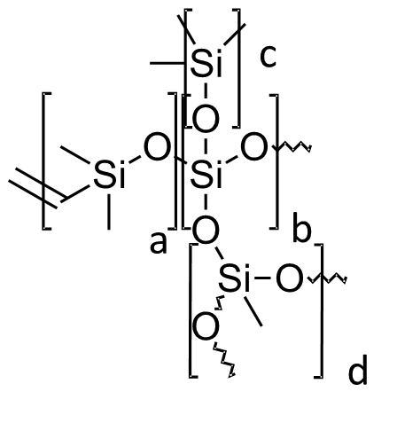



x

y

z

Figure 1. Mercapto MQT(SH) resin Figure 2. Vinyl functional VTQ resin

|  |  |  |  |  |  |  |  |
| --- | --- | --- | --- | --- | --- | --- | --- |
| Designation | Q / T (y/z) | Equivalent Weight | Viscosity (cPs) | Designation | a/b/c/d | *Vinyl % | *Viscosity (cPs) |
| SH 208 | 0% | 208 | 215 | Q83T30 | 25/100/55/30 | 1.84% | 25,500 |
| SH208-10Q | 10% | 217 | 530 | Q91T30 | 10/100/80/30 | 0.63% | 16,000 |
| SH208-20Q | 20% | 220 | 1,350 | Q92T30 | 20/100/70/30 | 1.33% | 18,000 |
| SH208-30Q | 30% | 226 | 2,325 | Q93T30 | 30/100/60/30 | 1.88% | 15,000 |
| SH208-40Q | 40% | 232 | 12,300 | Q94T30 | 40/100/50/30 | 2.49% | 14,000 |
| SH208-50Q | 50% | 238 | 228,000 | Q92T50 | 20/100/70/50 | 1.41% | 5,000 |
| * measured on 1;1 blend with 65K | | | | Q92 | 20/100/70/0 | 1.07% | 55,000 |
|  |  |  |  | Q93 | 30/100/60/0 | 1.62% | NA |
|  |  |  |  | Q94 | 40/100/50/0 | 2.15% | 65,000 |

Table 1. Mercapto Silicon Resin Structures. Table 2. Vinyl Silicon Resin Structures.

These experiments are conducted in a TA Instruments AR-G2 SN 10G4421 Rheometer with a UV reactive chamber. The geometry is set to 20 mm disposable plate and procedure set to UV fast with the thickness of 1000 µm. The reacted volume is ~1 mL and the UV laser emits at 365 nm. The rheological properties including G’, G’’, tan (δ) and cure rate are analyzed and obtained by the TA Rheology Advantage software.

The reactions are repeated on the benchtop. Prepared by mixing a 50 gm sample using the requisite amounts into a plastic or paper cup. Stir the mixture until homogenous and pour the mixture into a 6x6 inch mold. De-gas using the Lab-line vacuum chamber at -50 kPa for 5 minutes to remove air bubbles. Finally cure the mixture with Vogue Professional UV Lamp # ND362 for 10 minutes under a nitrogen blanket.

These 6x6 inch cured sheets are cut with ASTM D624 type C shape for tear strength measurement and ASTM D412 for tensile and elongation measurement. Bluehill 2 software is used according to the manufacturer’s instructions for testing.

The general formulation is 5-40% of the mercapto MQT resins, 15-25% of the vinyl functional VTQ resins, 50-70% di-vinyl functional 65,000 cps extender (herein referred to as 65K) and 0.6-0.7% TPO-L photoinitiator. The VTQ resins are first diluted in some of the extender for ease of handling.

Variables evaluated in these experiments includes the stoichiometry of the MQT(SH); VTQ; and 65K components. We also delve deeply into the structural parameters of each component. Specifically, the ratios of the MQT groups and the degree of reactive groups on each polymer.

The formulations were too viscous for our standard SLA type benchtop printer, so we jerry-rigged an UltiMaker 2+ FMD printer. The materials were extruded using a DISCOV3RY 2.0 two-part paste extruder. The extruder, printer and the 3D CAD files and firmware that interfaces them were designed from Structur3d Printing. We modified the nozzle block to feed the paste material. This is a thermal cured printer so we attached a UV lamp to the print head to effect UV curing.

**Results**

In a large number of experiments reported else where[1] we determined the optimum SH/vinyl stoichiometry. These critical parameters are summarized in Table 3. As we bring more Q groups into the resin stoichiometry, the needed ratio of SH/vinyl for optimal reaction increases.

In the same study we showed the higher Q resin materials -40Q and -50Q were not effective and they will not be further referenced in this report.

|  |  |  |  |  |  |  |
| --- | --- | --- | --- | --- | --- | --- |
|  | SH 208 | SH 208-10Q | SH 208-20Q | SH 208-30Q | SH 208-40Q | SH 208-50Q |
| Optimal SH/vinyl ratio | 2.33 | 2.46 | 3.05 | 4.44 | 6.75 | 6.85 |

Table 3: Optimized SH/vinyl ratios for SH 208 to SH 208-50Q.

Having established the optimum SH/vinyl ratio of 2.33 for the SH 208/65K/Q93T30 system, we next sought to show the effect of the Q groups directly. We repeated these experiments with the constant SH/vinyl ratio=2.33. Rheological and mechanical data are tabulated in Table 4.

|  |  |  |  |  |
| --- | --- | --- | --- | --- |
| Component | SH 208 | SH 208-10Q | SH 208-20Q | SH 208-30Q |
| SH 208 series | 13.76% | 14.23% | 14.43% | 14.75% |
| 65K | 46.44% | 46.13% | 46.07% | 45.91% |
| Q93T30 | 39.12% | 38.96% | 38.80% | 38.67% |
| TPO-L | 0.67% | 0.67% | 0.69% | 0.67% |
| SH/vinyl ratio | 2.33 | 2.33 | 2.34 | 2.34 |
| G' (Pa) | 6.65E+05 | 6.92E+05 | 7.53E+05 | 4.34E+05 |
| G" (Pa) | 4.75E+04 | 5.14E+04 | 5.42E+04 | 4.53E+04 |
| tan delta | 0.071 | 0.074 | 0.072 | 0.104 |
| Cure rate (Pa/s) | 1.62E+05 | 1.26E+05 | 1.28E+05 | 1.45E+05 |
| Appearance | opaque white | opaque white | opaque white | opaque white |
| Tensile Strength (kPa) | 2438.66 | 3258.12 | 3278.78 | 2374.05 |
| Elongation (%) | 79.18 | 84.50 | 79.65 | 68.59 |
| Total Energy (J/m) | 128.10 | 204.48 | 166.22 | 117.93 |
| Tear Strength (N/mm) | 2.78 | 3.01 | 3.59 | 3.59 |
| Shore A Hardness | 48 | 52 | 52 | 51 |
| Note | poor tear strength | | | |

Table 4. SH/vinyl ratio set to 2.33

Cured samples prepared with SH 208-10Q and 20Q have better storage modulus, tensile strength, tear strength and Shore A hardness compared to the sample prepared with SH 208. This indicates that introducing 10% to 20% Q group into the vinyl MT resin provides improvements from the increased cross-linking.

Although SH 208-10Q and 20Q samples give reasonable tensile strength of about 3 MPa, all of the samples in shown table 4 have poor toughness. All samples break upon twisting.

Because the results reported in Table 4 suggest that SH/vinyl ratio of 2.33 may not be the optimal ratio for all of the mercapto silicon resins, a SH/vinyl ratio study is performed by adding more mercapto silicon to increase SH/vinyl ratio. Rheological and mechanical data of optimal SH/vinyl ratio and % increase data are tabulated in table 5.

|  |  |  |  |  |  |  |
| --- | --- | --- | --- | --- | --- | --- |
|  | SH 208-10Q | delta | -20Q | delta | -30Q | delta. |
| SH/vinyl ratio | 2.46 | 5% | 3.05 | 30% | 4.44 | 90% |
| Tensile Strength (kPa) | 3167.24 | -3% | 3006.54 | -8% | Not Measured | |
| Elongation (%) | 84.78 | 0% | 87 | 9% |
| Total Energy (J/m) | 170.76 | -16% | 172.77 | 4% |
| Tear Strength (N/mm) | 3.2 | 6% | 1.96 | -45% |
| Shore A Hardness | 50 | -4% | 49 | -6% |
| G' (Pa) | 7.11E+05 | 3% | 8.43E+05 | 12% | 7.36E+05 | 69% |
| G" (Pa) | 5.14E+04 | 0% | 5.95E+04 | 10% | 5.97E+04 | 32% |
| tan delta | 0.072 | -3% | 0.071 | -2% | 0.081 | -22% |
| Cure rate (Pa/s) | 1.79E+05 | 42% | 2.47E+05 | 93% | 1.51E+05 | 4% |

Table 5. Rheological and mechanical data for SH 208-10Q to -30Q at optimal SH/vinyl ratio

Optimizing the SH/vinyl ratio did give the maximum storage moduli. Notice that the G’ of the sample with SH/vinyl = 3.05 increases by 12%. This shows that a greater SH/vinyl ratio is required in the MQT(SH) samples with more Q groups. In comparison to data measured at SH/vinyl=2.33, the G’, G” and cure rate all increased at the optimal SH/vinyl ratio.

Tables 4-5 show that the sample toughness is not dictated by the amount of MQT(SH) in the formulation. Adjusting for optimal SH/vinyl ratio did not improve tensile strength, tear strength and Shore A hardness in SH 208-10Q and SH 208-20Q samples.

We next examine the amount of 65K. Recall that this diluent is also reactive and affects the final properties. In the following data, we add more 65K to the some of the formulations just examined and note the effect.

|  |  |  |  |  |  |  |
| --- | --- | --- | --- | --- | --- | --- |
| Component | -10Q w/+10% 65K | | -20Qw/+5% 65K | | -30Q w/+5% 65K | |
| SH 208-xQ | 12.24% |  | 16.44% |  | 17.96% |  |
| 65K | 55.81% |  | 49.23% |  | 51.71% |  |
| VQ93T30/VIN65K | 31.26% |  | 33.67% |  | 29.84% |  |
| TPO-L | 0.69% |  | 0.67% |  | 0.49% |  |
| SH/vinyl ratio | 2.46 |  | 3.05 |  | 3.63 |  |
| Property |  | **delta** |  | **delta** |  | **delta** |
| Tensile Strength (kPa) | 2495.98 | -21% | 2450.47 | -18% | 2898.85 | 14% |
| Elongation (%) | 122.1 | 44% | 97.1 | 12% | 130.64 | 40% |
| Total Energy (J/m) | 209.75 | 23% | 162.97 | -6% | 283.56 | 76% |
| Tear Strength (N/mm) | 3.27 | 2% | 2.67 | 36% | 3.92 | 39% |
| Shore A Hardness | 38 | -24% | 42 | -14% | 40 | -2% |
| G' (Pa) | 3.62E+05 | -49% | 5.40E+05 | -36% | 4.70E+05 | -25% |
| G" (Pa) | 2.49E+04 | -52% | 3.76E+04 | -37% | 3.66E+04 | -26% |
| tan delta | 0.069 | -4% | 0.07 | -1% | 0.078 | 0% |
| Cure rate (Pa/s) | 1.35E+05 | -25% | 5.54E+04 | -78% | 1.21E+05 | -22% |
| Appearance | more flexible | | | | | |

Table 6. Impact of adding 5-10% more 65K reactive diluent

Table 6 shows that elongation, tear strength and twistability are all improved after adding 5-10 wt% more 65K. However, this does reduce hardness, tensile strength, storage modulus and cure rate. Thus, for tear strength and toughness improvement, no more than 5% linear high MW vinyl terminated siloxane (65K) can be tolerated.

Among the three samples compared, SH 208-30Q gives the highest tensile strength, elongation, total energy and tear strength after adding 5% more 65K.

Next, we examine the VTQ resin. This is the vinyl functional component that reacts with the mercapto groups. We look first at the M(V)/Q ratio. [b/a in Figure 2] Two different VTQ samples VQ83T30 and VQ93T30 are evaluated in SH 208-30Q/VTQ/VIN system for rheological and mechanical properties. VQ83T30 has a M/Q ratio of 0.8:1 and VQ93T30 has a M/Q ratio of 0.9:1. In other words, more Q groups are present in VQ83T30. Both of these are evaluated at a SH/vinyl ratio of 3.63.

|  |  |  |  |  |
| --- | --- | --- | --- | --- |
| Component | M/Q=0.9 | M/Q=0.8 | M/Q=0.8 + 5 wt% 65K |  |
| SH 208-30Q | 17.96% | 17.60% | 15.81% |  |
| 65K | 51.71% | 52.09% | 57.07% |  |
| VQT83-30/VIN65K | 0.00% | 29.80% | 26.51% |  |
| VQ93T30/VIN65K | 29.84% | 0.00% | 0.00% |  |
| TPO-L | 0.49% | 0.51% | 0.62% |  |
| Property |  |  |  | **Delta** |
| SH/vinyl ratio | 3.63 | 3.63 | 3.62 | 0% |
| Tensile Strength (kPa) | 2898.85 | 2587.3 | 3186.03 | -23% |
| Elongation (%) | 130.64 | 85.5 | 148.51 | -74% |
| Total Energy (J/m) | 283.56 | 149.77 | 387.83 | -159% |
| Tear Strength (N/mm) | 3.92 | 4.32 | 4.63 | -7% |
| Shore A Hardness | 40 | 49 | 42 | 14% |
| G' (Pa) | 4.70E+05 | 5.97E+05 | 4.39E+05 | 26% |
| G" (Pa) | 3.66E+04 | 3.60E+04 | 2.82E+04 | 22% |
| tan delta | 0.078 | 0.06 | 0.064 | -7% |
| Cure rate (Pa/s) | 1.21E+05 | 1.73E+05 | 4.04E+04 | 77% |
| Appearance | very flexible, leaves no marks after twisting. | very flexible, leaves no marks after twisting. | very flexible, maybe marks after twisting |  |

Table 7. Impact of M/Q ratio in VTQ component on 208-30Q

Table 7 suggests that VQ83T30 has greater tear strength, hardness, storage modulus and cure rate than VQ93T30. The M/Q=0.8 material gives a more crosslinked and tougher resin than M/Q=0.9. However, it also gives less tensile strength, elongation, total energy under the area in comparison to VQ93T30. Similar to the results when changes were made to the MQT(SH) component, these formulations are improved by adding 5 wt% of 65K. This is expected when adding a chain extender.

We next evaluated the vinyl content in the 65K for SH/VTQ/VIN system. We prepared two different 65K products. The difference between these two batches is vinyl contents of 0.060% and 0.078% vinyl respectively. These were evaluated using the SH 208-30Q and VQT83-30 resins.

|  |  |  |
| --- | --- | --- |
| Component | 0.060% vinyl | 0.078% vinyl |
| SH 208-30Q | 20.84% | 21.04% |
| 65K (0.060% vinyl) | 42.64% | 0.00% |
| 65K (0.078% vinyl) | 0.00% | 42.50% |
| VQT83-30/65K | 35.92% | 35.86% |
| TPO-L | 0.61% | 0.60% |
| SH/vinyl ratio | 3.63 | 3.63 |
| Tensile Strength (kPa) | 3571.56 | 4037.85 |
| Elongation (%) | 73.71 | 84.8 |
| Total Energy (J/m) | 209.13 | 238.75 |
| Tear Strength (N/mm) | 3.46 | 5.11 |
| Shore A Hardness | 59 | 57 |
| G' (Pa) | 1.05E+06 | 1.09E+06 |
| G" (Pa) | 7.46E+04 | 6.54E+04 |
| tan delta | 0.071 | 0.06 |
| Cure rate (Pa/s) | 1.83E+05 | 1.76E+05 |
| Appearance | tears easily | very flexible, good twist |

Table 8. Impact of vinyl content in 65K component on 208-30Q

It is shown in Table 8 that that higher vinyl content 0.075% 65K gives better tensile strength, tear strength and twist. The sample prepared with lower vinyl (0.060%) 65K (11906018) breaks immediately upon twisting whereas the 0.075% formula withstands a good twist.

Next, we examine the vinyl content in the VTQ resin. [a/c in Figure 2]. Four analogous VTQ resins based on VQxT30 with different vinyl contents are evaluated in SH/VTQ/VIN system for rheological and mechanical properties. These samples have the same amount of T group and M/Q ratio. They are designated VQ91T30 (0.63% vinyl, 16200 cps); VQ92T30 (1.33%, 18000 cps); VQ93T30 (1.88%, 14600 cps); and VQ94T30 (2.49%, 14000 cps).

|  |  |  |  |  |
| --- | --- | --- | --- | --- |
| Component | VTQ 0.626% Vinyl | VTQ 1.33% Vinyl | VTQ 1.88% Vinyl | VTQ 2.49% Vinyl |
| SH 208-20Q | 8.12% | 12.44% | 14.43% | 16.53% |
| 65K | 25.87% | 39.67% | 46.07% | 49.09% |
| VQxT30 | 65.31% | 47.20% | 38.80% | 33.75% |
| TPO-L | 0.71% | 0.70% | 0.69% | 0.63% |
| SH/vinyl ratio | 2.35 | 2.34 | 2.34 | 2.33 |
| Tensile Strength (kPa) | 1924.43 | 4923.25 | 3278.78 | not measured |
| Elongation (%) | 113.88 | 95.8 | 79.65 |
| Total Energy (J/m) | 115.58 | 248.89 | 166.22 |
| Tear Strength (N/mm) | 3.12 | 3.54 | 3.59 |
| Shore A Hardness | 27 | 46 | 52 |
| G' (Pa) | 1.63E+05 | 4.61E+05 | 7.53E+05 | 7.73E+05 |
| G" (Pa) | 2.70E+04 | 4.67E+04 | 5.42E+04 | 4.47E+04 |
| tan delta | 0.166 | 0.101 | 0.072 | 0.058 |
| Cure rate (Pa/s) | 3.57E+04 | 8.04E+04 | 1.28E+05 | 2.79E+05 |

Table 9. Impact of vinyl content in VTQ component on 208-20Q

It is observed in Table 9 that as vinyl content increases in VTQ resin, storage modulus, tear strength, hardness and cure rate increase whereas elongation decreases. This indicates as expected that higher vinyl content in the VTQ resin results in higher crosslinking.

Hardness and tensile strength data indicate that VQ91T30 is too weak because of its low vinyl functionality. Hardness and tear strength data suggest VQ93T30 is the best among these 4 VTQ samples tested. Both VQ93T30 and VQ94T30 samples give good toughness and twist.

The above formulations were evaluated with more 65K than optimum to maximize tear strength. Recall that tear strength improves as 65K extender is increased. The summary of these improved preparations is shown in Table 10 where 1.88% and 2.49% vinyl examples were improved by adjusting the SH/vinyl content.

|  |  |  |  |  |
| --- | --- | --- | --- | --- |
| Component | VTQ 0.626% Vinyl | VTQ 1.33% Vinyl | VTQ 1.88% Vinyl | VTQ 2.49% Vinyl |
| SH 208-20Q | 8.12% | 12.44% | 13.14% | 13.27% |
| 65K | 25.87% | 39.67% | **51.13%** | **59.03%** |
| VQxT30 | 65.31% | 47.20% | 35.06% | 27.12% |
| TPO-L | 0.71% | 0.70% | 0.68% | 0.59% |
| SH/vinyl ratio | 2.35 | 2.34 | 2.34 | 2.29 |
| Tensile Strength (kPa) | 1924.43 | 4923.25 | 3594.64 | 2861.09 |
| Elongation (%) | 113.88 | 95.8 | 108.63 | 128.49 |
| Total Energy (J/m) | 115.58 | 248.89 | 288.86 | 301.43 |
| Tear Strength (N/mm) | 3.12 | 3.54 | **5.26** | **4.54** |
| Shore A Hardness | 27 | 46 | 48 | 45 |
| G' (Pa) | 1.63E+05 | 4.61E+05 | 4.83E+05 | 5.11E+05 |
| G" (Pa) | 2.70E+04 | 4.67E+04 | 3.65E+04 | 3.00E+04 |
| tan delta | 0.166 | 0.101 | 0.076 | 0.059 |
| Cure rate (Pa/s) | 3.57E+04 | 8.04E+04 | 8.33E+04 | 2.30E+05 |
| Appearance | soft | firm with okay tear | firm with good tear | firm with okay tear |

Table 10. Impact of vinyl content in VTQ component on SH208-20Q – maximal tear strength

The effect of the amount of T groups in VTQ resin is also studied in SH/VTQ/VIN system for better tear strength and toughness. These three samples have the same vinyl content in VQ but different amounts of T/Q groups from 0 to 50%. [z/y in Figure 1]

|  |  |  |  |  |
| --- | --- | --- | --- | --- |
| Component | VQ92T0 | VQ92T30 | VQ92T30  +5% xs 65K | VQ92T50  +5% xs 65K |
| SH 208-20Q | 10.15% | 12.44% | 11.25% | 11.56% |
| 65K | 41.09% | 39.67% | 45.40% | 46.52% |
| VQ92Tx | 48.07% | 47.20% | 42.71% | 41.24% |
| TPO-L | 0.70% | 0.70% | 0.63% | 0.68% |
| SH/vinyl ratio | 2.32 | 2.34 | 2.32 | 2.33 |
| Tensile Strength (kPa) | 5524.11 | 4923.25 | 4293.6 | 2816.47 |
| Elongation (%) | 87 | 95.8 | 111.49 | 105.43 |
| Total Energy (J/m) | 284.75 | 248.89 | 288.53 | 163.51 |
| Tear Strength (N/mm) | 4.9 | 3.54 | 3.46 | 3.17 |
| Shore A Hardness | 58 | 46 | 44 | 31 |
| G' (Pa) | 9.14E+05 | 4.61E+05 | 4.25E+05 | 2.22E+05 |
| G" (Pa) | 7.28E+04 | 4.67E+04 | 3.56E+04 | 1.68E+04 |
| tan delta | 0.08 | 0.101 | 0.084 | 0.076 |
| Cure rate (Pa/s) | 3.19E+05 | 8.04E+04 | 1.06E+05 | 5.27E+04 |
| Appearance | Tough. Can be twisted. | Firm, can be twisted without break | Break after twisting | Soft, break upon twisting |

Table 11. Impact of T group in VTQ component on SH208-20Q.

Table 11 shows that the VTQ resin with zero T [d=0 Figure 2] groups gives the best rheological and mechanical properties. This is a tough material with excellent tear strength at 4.9 N/mm, fast cure rate and moderate hardness. The other samples also indicate that introducing T group to the VQ resin lowers both mechanical and rheological properties. This is likely again a steric hindrance effect. However, T groups are useful as an aid for viscous material, because including T groups in the VTQ resin lowers the viscosity.

Next, we evaluate the effect of vinyl content in VQ resin without T groups. We prepare three VQ resins which the same M/Q ratio and with slightly different ratios of V/Q. VQ92(1.07% vinyl); VQ93(1.62% vinyl); VQ94 (2.15% vinyl). Reaction with SH208-30Q is the basis for the evaluation.

|  |  |  |  |
| --- | --- | --- | --- |
| Component | 1.07% vinyl | 1.62% vinyl | 2.15% vinyl |
| SH 208-30Q | 10.56% | 14.88% | 18.54% |
| 65K | 54.86% | 52.33% | 49.97% |
| VQx | 33.82% | 32.02% | 30.74% |
| TPO-L | 0.76% | 0.77% | 0.75% |
| SH/vinyl ratio | 3.21 | 3.23 | 3.21 |
| Tensile Strength (kPa) | 3957.38 | 1642.08 | 2907.32 |
| Elongation (%) | 156.51 | 65.09 | 75.2 |
| Total Energy (J/m) | 550.25 | 79.41 | 185.8 |
| Tear Strength (N/mm) | 6.95 | 3.8 | 4.84 |
| Shore A Hardness | 44 | 50 | 56 |
| G' (Pa) | 4.71E+05 | 7.20E+05 | 1.26E+06 |
| G" (Pa) | 3.47E+04 | 4.35E+04 | 6.90E+04 |
| tan delta | 0.074 | 0.06 | 0.055 |
| Cure rate (Pa/s) | 1.21E+05 | 1.70E+05 | 1.84E+05 |
| Appearance | Very tough material, very flexible, white opaque | breaks upon twisting | breaks upon twisting |

Table 12. Impact of vinyl content in VQ component on SH208-30Q

Table 12 shows that Silmer VQ92 (1.07% vinyl) gives the best tear strength, 6.95 N/mm, among all samples tested in this project. This formulation also has the best elongation in the study, good tensile strength and suitable hardness for 3D UV printing.

It is also observed that higher vinyl content in VQ gives greater hardness, storage modulus and cure rate.

We 3D printed the VQ92 (1.07% vinyl) formulation show in the first column of table 12. The materials were white, opaque with good mechanical properties. Additional formulations from which we printed additives are shown in table 13.

|  |  |  |
| --- | --- | --- |
| Component | YL2-153A | YL2-153B |
| Proprietary MQT(SH) resins | 21.47% | 15.05% |
| 65K | 42.30% | 45.75% |
| VQT83-30 | 35.64% | 38.55% |
| TPO-L | 0.59% | 0.64% |
| SH/vinyl | 3.63 | 3.63 |
| Tensile Strength (kPa) | 3,495.98 | 2,303.68 |
| Elongation (%) | 99.07 | 55.87 |
| Total Energy (J/m) | 262.95 | 104.34 |
| Tear Strength (N/mm) | 6.81 | 5.33 |
| Shore A Hardness | 55.00 | 53.00 |
| G' (Pa) | 6.41E+05 | 1.20E+06 |
| G" (Pa) | 1.14E+05 | 5.23E+04 |
| tan delta | 0.18 | 0.04 |
| Cure rate (Pa/s) | 8.65E+04 | 2.87E+05 |

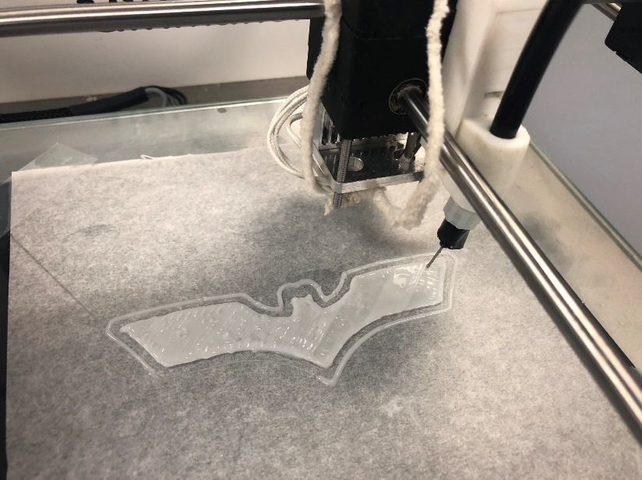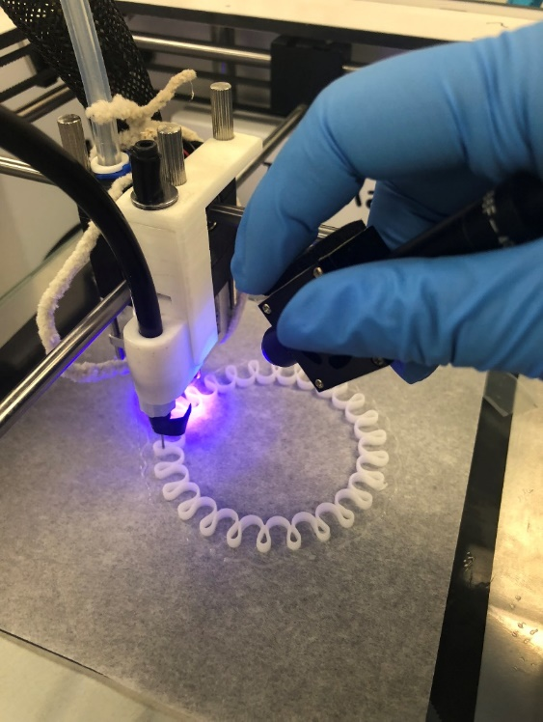Table 13: formulations that were 3D printed.

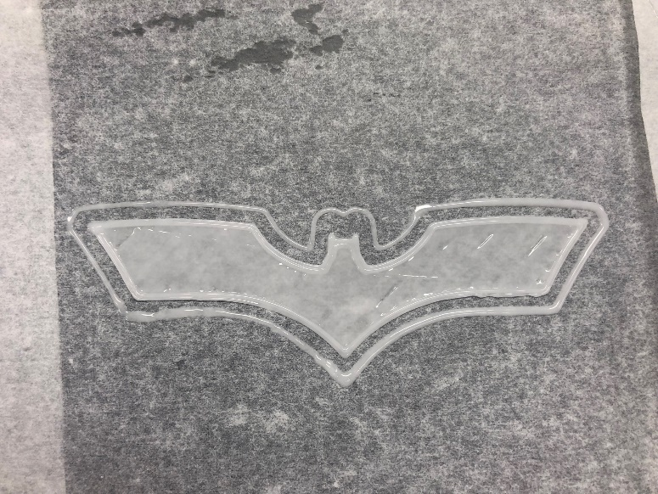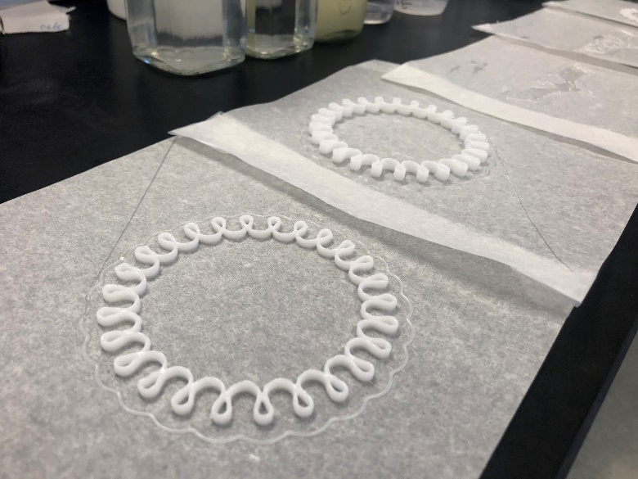Figure 3: YL2-153B formulation being 3D printed with hand held UV light.

Figure 4: final additive pieces.

**Conclusion**

Regarding the VQT(SH) resin, the lower amounts of Q groups give good performance, using more Q than the SH 208-30Q results in decreased properties. SH 208-20Q and SH 208-3Q gave the best balance of properties.

Regarding the VTQ resin, M/Q ratios of 0.8 are better than 0.9. We did not explore the boundary of this trend, i.e. would M/Q of 0.7 be even better? In our experience this M/Q ratio is not stable enough for commercial use.

Introducing T groups in the VTQ resin provides lower viscosity as intended, but hardness and toughness suffer quickly. In fact, the VQ (T=0) resins performed the best – independent of viscosity considerations.

The stoichiometry of SH/vinyl is a critical parameter. Too much VQ resin can hurt properties. For the VQT(SH) resins specified above, up to about 17% VQ resin is positive, beyond that properties are lost.

Regarding the 65K, divinyl silicone chain extender, increasing the amount of this product gives elongation and tear strength improvements but this comes with a large reduction of hardness and tensile strength. No more than 5% excess is recommended.

Increasing the vinyl content of the 65K gave improved tensile strength, tear strength and flexibility.

We did isolate formulations for 3D printing and were able to print multiple additive parts with good properties. We used an UltiMaker 2+ FMD from Sturctra3D for 3D printing of the SH formulations due to the relatively high viscosity. This is a thermal cured printer so we attached a UV lamp to the print head to effect UV curing or held the light by hand.

Further optimization of this work into a commercial product will be guided by the conclusions on this report and customer’s needs.

1. Ruckle et.al. Proceedings of the Waterborne Symposium, 2020.